Assignment No. 2
High-Level Use Cases
University Timetable Optimization and Management System
Software Engineering Subject

Project: | University Timetable Optimization and Management System
Prepared For: | Course Instructor / Examiner
Prepared By: | Student Name / Registration No.
Submission Date: | ________________

Department of Computer Science / Software Engineering
University Assignment Report

1. Purpose and Scope
This document defines the high-level use cases for the University Timetable Optimization and Management System. The focus is on user goals and system responsibilities, not on low-level event flows or algorithm design. The first version assumes course and section scheduling within a department or faculty context, with timetable generation, review, controlled change handling, publication, and reporting.
The modelling objective is to keep the abstraction level consistent. For that reason, holidays are included within calendar maintenance instead of being treated as a separate peer use case, and business dependencies such as “review before publish” are described in text rather than forced into incorrect UML include/extend links.
2. External Actors
Actor | Role in the system | Typical interaction
Timetable Administrator | Primary operational actor | Maintains core data, configures rules, generates drafts, approves adjustments, publishes results.
Department Coordinator | Validation and coordination actor | Checks scheduling data, participates in review, and requests justified timetable changes.
Teacher | End user and change requester | Views assigned timetable and submits change requests when needed.
Student | End user | Views the published timetable relevant to a section, semester, or student group.
Facility Manager | Resource oversight actor | Reviews room usage and resource-related reports.

3. System Context Diagram
A context diagram shows the timetable system as a single black-box boundary surrounded by external actors. It does not contain use-case ovals and it does not model UML include/extend semantics. Its purpose is only to show who is outside the system and what kind of interaction they have with it.
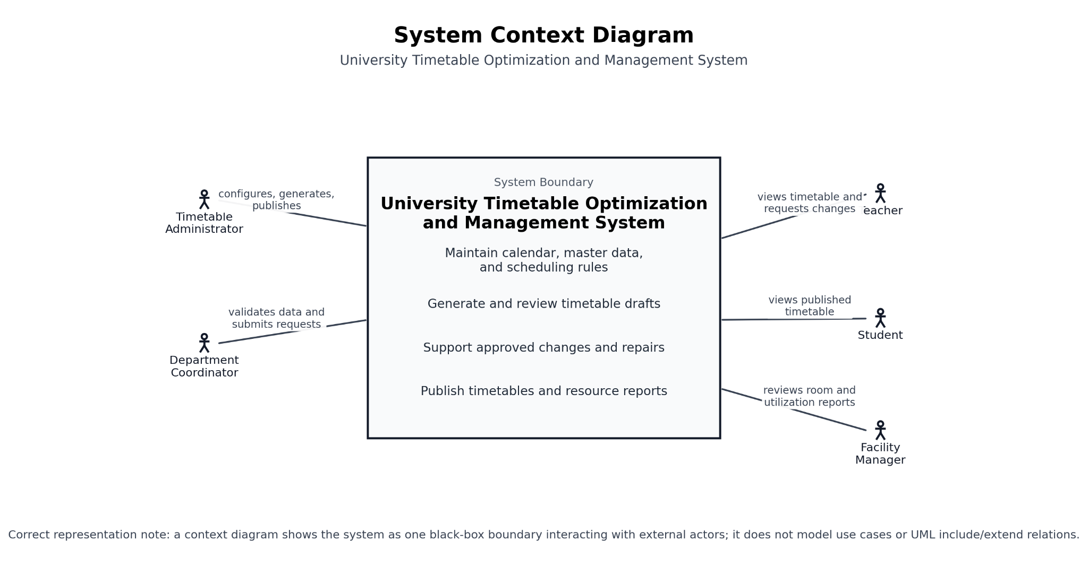
Figure 1. System context diagram for the University Timetable Optimization and Management System.
3.1 Diagram Description
The figure places one system boundary in the center and all external actors around it. The Timetable Administrator configures, generates, and publishes. The Department Coordinator validates data and submits requests. Teachers and students mainly consume timetable outputs, while the Facility Manager focuses on room and utilization reporting. This representation is correct for a context diagram because the system is shown as one black box rather than as a set of internal use cases.
4. High-Level UML Use Case Diagram
The use case diagram below models only actor–use case associations. It intentionally avoids questionable include/extend relations because the dependencies in this project are mostly business preconditions rather than reusable use-case behaviour.
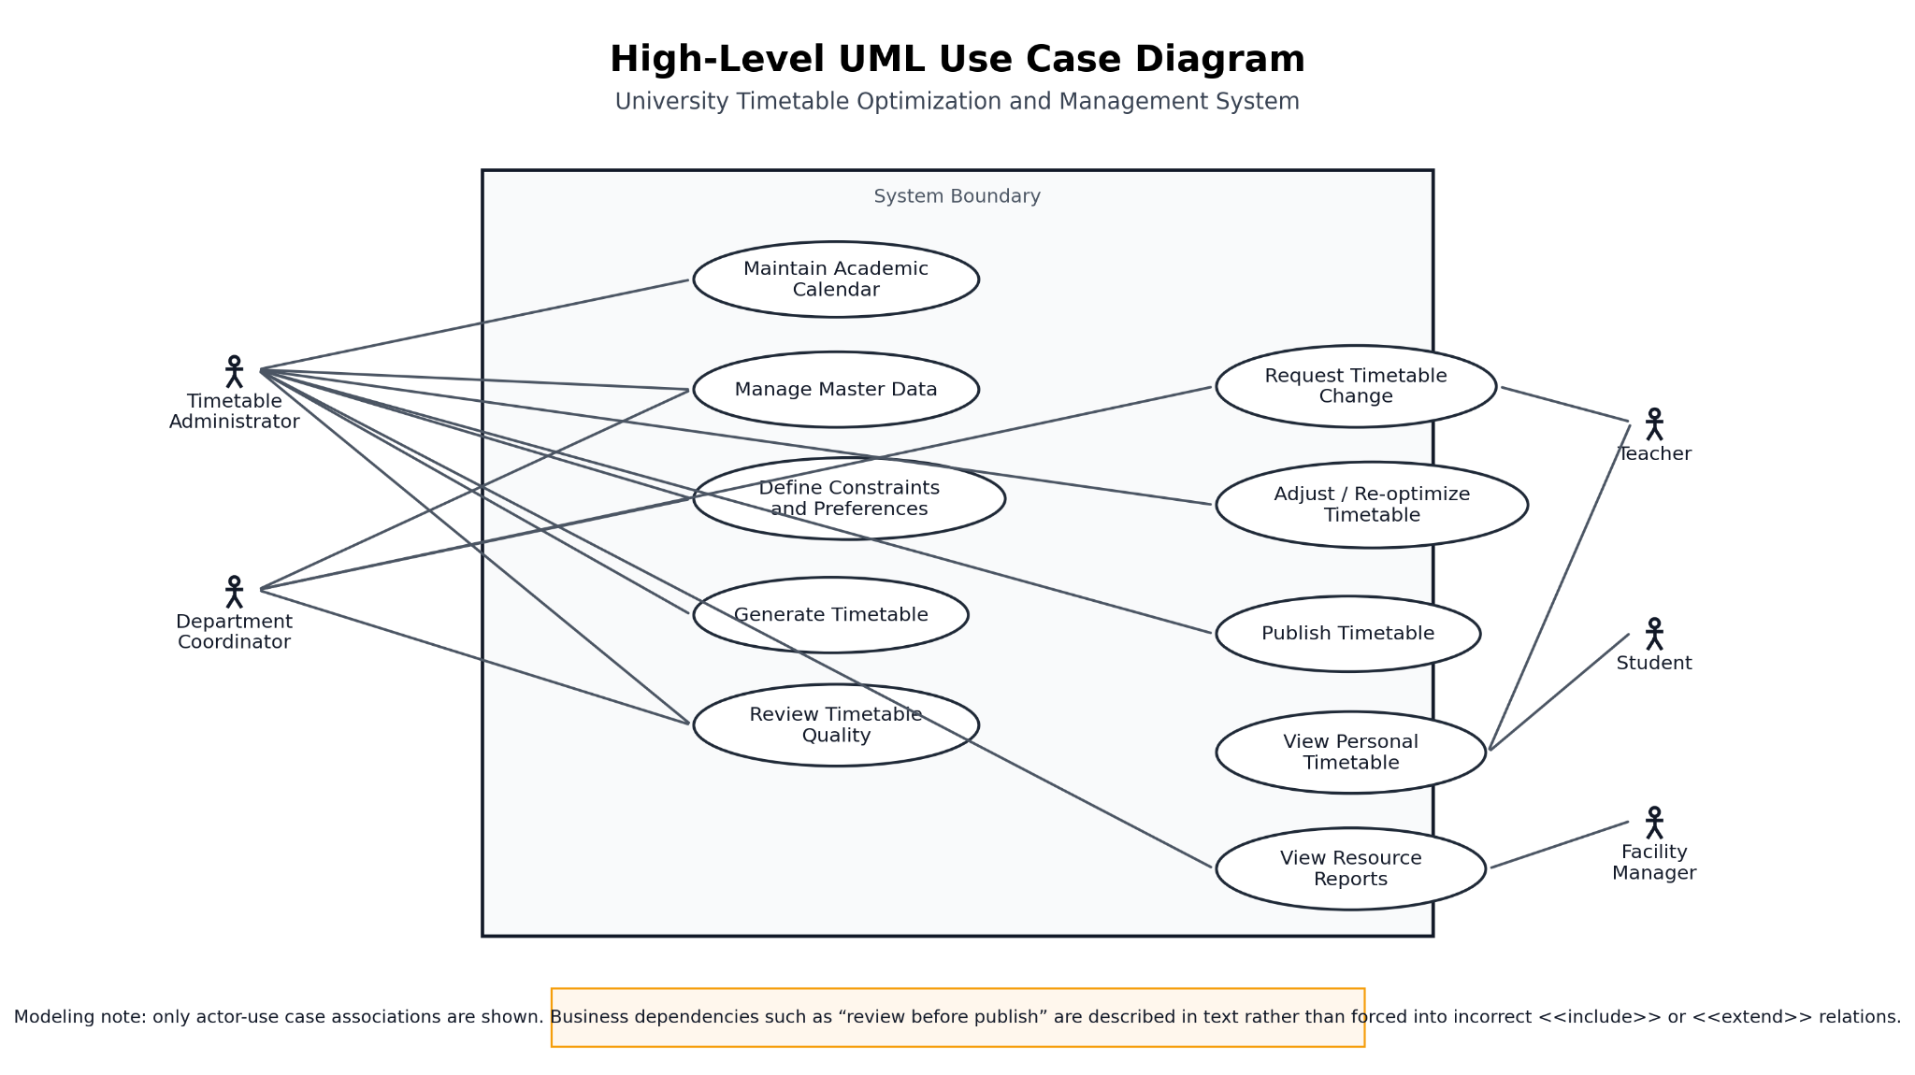
Figure 2. High-level UML use case diagram.
4.1 Diagram Description
The diagram contains one clear system boundary and ten high-level use cases. Actors remain outside the boundary. The Timetable Administrator is the main operational actor, while the Department Coordinator participates in validation and change requests. Teachers request changes and view personal timetables; Students only view published timetables; and the Facility Manager reviews resource reports. Only direct associations are shown. Dependencies such as “generate using configured constraints” or “publish after review” are described narratively in the document rather than misrepresented with UML relations that would not be semantically correct here.
5. Use Case Modelling Rules Used
- All use cases are kept at a high level so that they represent user goals, not low-level interface actions.
- Calendar maintenance includes holidays and blocked periods; these are not separated into another overlapping peer use case.
- Teacher change requests and administrator timetable adjustment are kept separate because they are different goals performed by different actors.
- Manual locking of decisions is treated as an internal behaviour of timetable adjustment, not as a standalone high-level use case.
- Business ordering and preconditions are described in text; they are not forced into UML include/extend notation unless the semantics are genuinely correct.
6. High-Level Use Case Catalogue
UC01 – Maintain Academic Calendar
Use Case | Maintain Academic Calendar
Actors | Timetable Administrator
Type | Primary
Essential | Define the working calendar for timetable generation, including term dates, teaching days, holidays, and blocked periods.
Real | The administrator records semester dates, university holidays, no-class periods, and special event days so that classes are never scheduled in invalid time windows.

UC02 – Maintain Scheduling Data
Use Case | Maintain Scheduling Data
Actors | Timetable Administrator, Department Coordinator
Type | Primary
Essential | Maintain the academic and resource data required for scheduling.
Real | The administrator records departments, programs, courses, sections, teachers, rooms, capacities, buildings, and timeslots; the coordinator validates that the data reflects the real teaching structure.

UC03 – Configure Constraints and Preferences
Use Case | Configure Constraints and Preferences
Actors | Timetable Administrator, Department Coordinator
Type | Primary
Essential | Specify the rules and policy priorities that guide timetable generation.
Real | The administrator configures teacher availability, room suitability, class conflicts, room proximity preferences, morning priorities, early finish targets, and other approved institutional rules.

UC04 – Generate Timetable
Use Case | Generate Timetable
Actors | Timetable Administrator
Type | Primary
Essential | Produce a feasible timetable draft from the configured data and rules.
Real | The administrator starts timetable generation and the system creates an initial weekly schedule for teachers, classes, rooms, and student groups.

UC05 – Review Timetable Quality
Use Case | Review Timetable Quality
Actors | Timetable Administrator, Department Coordinator
Type | Primary
Essential | Assess whether the generated timetable is acceptable.
Real | The system shows clashes, rule violations, room usage, timetable compactness, and draft quality so that the administrator and coordinator can decide whether revision is needed.

UC06 – Request Timetable Change
Use Case | Request Timetable Change
Actors | Teacher, Department Coordinator
Type | Primary
Essential | Submit a justified request for timetable modification.
Real | A teacher or coordinator requests a change because of leave, room issues, special academic needs, or other approved reasons.

UC07 – Adjust / Re-optimise Timetable
Use Case | Adjust / Re-optimise Timetable
Actors | Timetable Administrator
Type | Primary
Essential | Modify an existing timetable while preserving accepted decisions as much as possible.
Real | After reviewing the draft or receiving an approved change request, the administrator adjusts the timetable and re-optimises it with minimal unnecessary disruption.

UC08 – Publish Approved Timetable
Use Case | Publish Approved Timetable
Actors | Timetable Administrator
Type | Primary
Essential | Release the accepted timetable for operational use.
Real | Once the draft is reviewed and approved, the administrator publishes the timetable so that teachers and students can access the official version.

UC09 – View Personal Timetable
Use Case | View Personal Timetable
Actors | Teacher, Student
Type | Primary
Essential | Access the timetable relevant to the logged-in user.
Real | A teacher views the assigned teaching schedule, while a student views the timetable of the relevant section, semester, or group.

UC10 – View Resource Reports
Use Case | View Resource Reports
Actors | Timetable Administrator, Facility Manager
Type | Secondary
Essential | Inspect reports related to room and timetable resource usage.
Real | The administrator and facility manager review room utilization, building load, and other operational reports after the timetable has been generated or published.

7. Business Dependency Notes
- A timetable draft can only be generated after scheduling data and constraints have already been maintained.
- Timetable review follows timetable generation as a business step, but it is not modeled with UML include because review is not reusable sub-behaviour executed inside generation.
- Publishing follows successful review and acceptance. This is treated as a business precondition rather than as an include relation.
- A change request may lead to timetable adjustment, but the request itself and the adjustment activity remain separate use cases because they belong to different actors and different goals.
8. Use Case Summary Matrix
ID | Use case | Main actor(s) | Type | Main output/result
UC01 | Maintain Academic Calendar | Timetable Administrator | Primary | Define the working calendar for timetable generation, including term dates, teaching days, holidays, and blocked periods
UC02 | Maintain Scheduling Data | Timetable Administrator, Department Coordinator | Primary | Maintain the academic and resource data required for scheduling
UC03 | Configure Constraints and Preferences | Timetable Administrator, Department Coordinator | Primary | Specify the rules and policy priorities that guide timetable generation
UC04 | Generate Timetable | Timetable Administrator | Primary | Produce a feasible timetable draft from the configured data and rules
UC05 | Review Timetable Quality | Timetable Administrator, Department Coordinator | Primary | Assess whether the generated timetable is acceptable
UC06 | Request Timetable Change | Teacher, Department Coordinator | Primary | Submit a justified request for timetable modification
UC07 | Adjust / Re-optimise Timetable | Timetable Administrator | Primary | Modify an existing timetable while preserving accepted decisions as much as possible
UC08 | Publish Approved Timetable | Timetable Administrator | Primary | Release the accepted timetable for operational use
UC09 | View Personal Timetable | Teacher, Student | Primary | Access the timetable relevant to the logged-in user
UC10 | View Resource Reports | Timetable Administrator, Facility Manager | Secondary | Inspect reports related to room and timetable resource usage
9. Conclusion
This high-level use case model is intentionally conservative and correct in representation. The context diagram uses a single black-box boundary, the UML use case diagram places actors outside one clear system boundary, and the document avoids forcing business dependencies into questionable include/extend notation. The resulting model is therefore more accurate, cleaner, and academically safer for the University Timetable Optimization and Management System project.
References
- Larman, C. (2004). Applying UML and Patterns (3rd ed.). Prentice Hall.
- Sommerville, I. (2016). Software Engineering (10th ed.). Pearson.
- Booch, G., Rumbaugh, J., & Jacobson, I. (2005). The Unified Modeling Language User Guide (2nd ed.). Addison-Wesley.

